



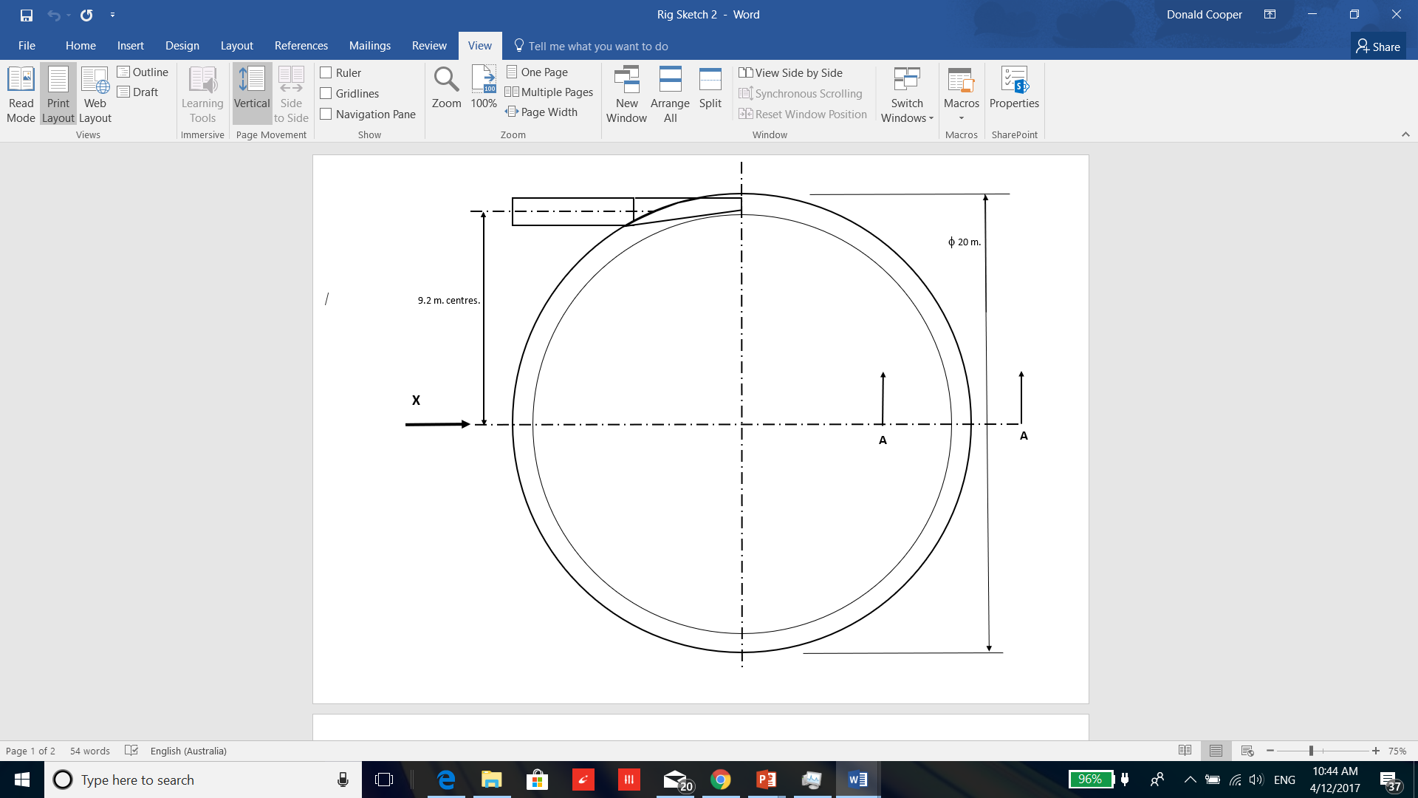

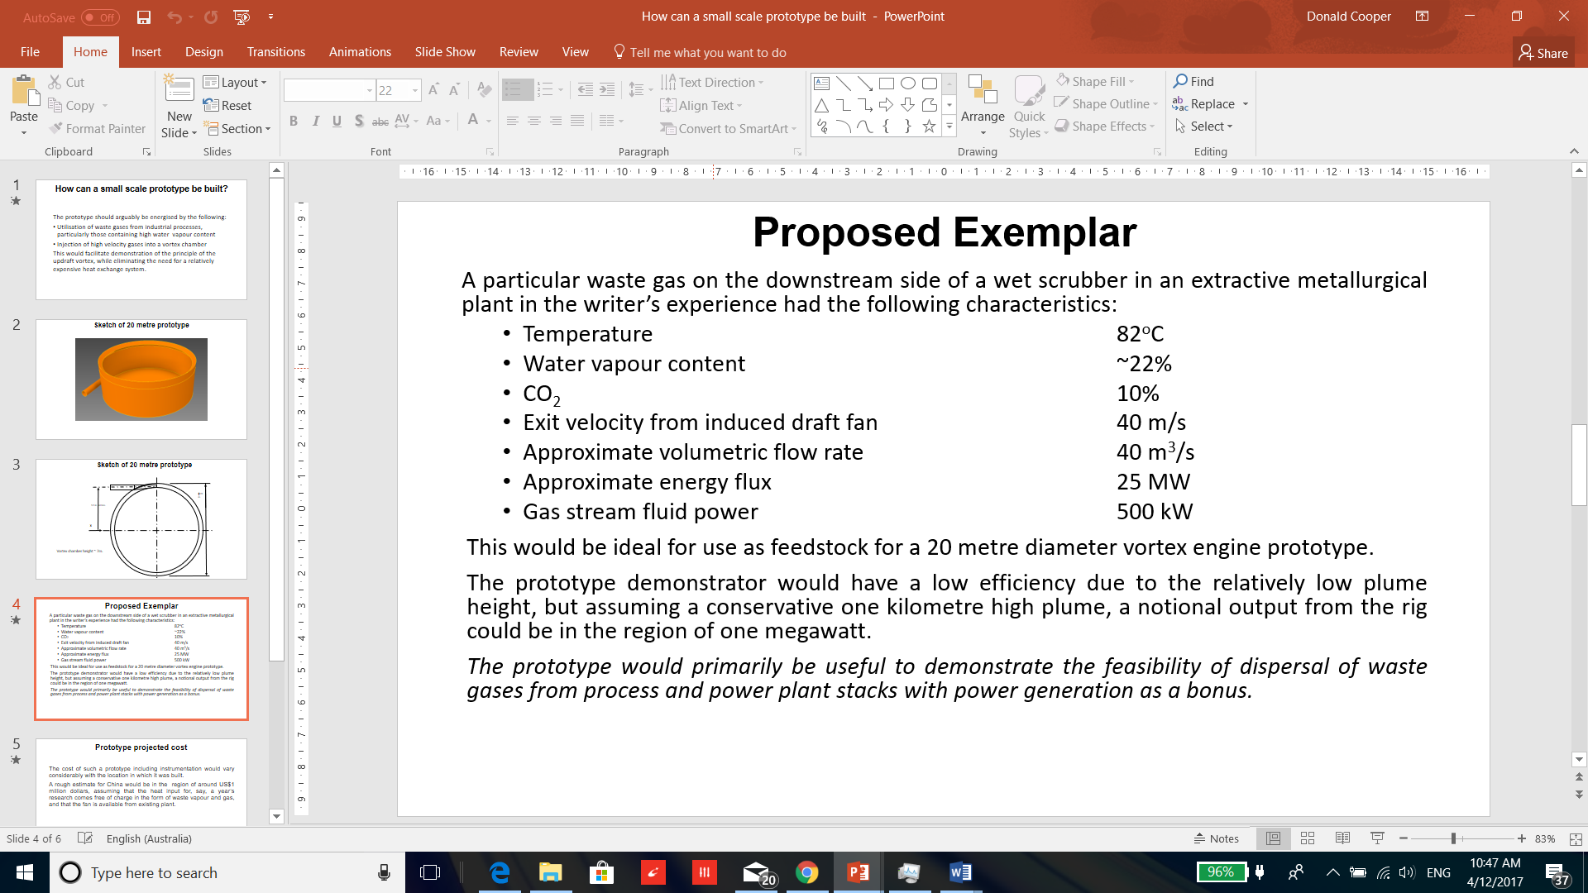

*“…What’s necessary at this point is to do proofs of concept,” says professor* ***Kerry Emanuel****, the hurricane expert at MIT. “Michaud’s idea is pretty simple and elegant. My own feeling is that we ought to be pouring money into all kinds of alternative energy research. There’s almost nothing to lose in trying this...”*

**ODE Magazine**, March 2008